**ASSIGNMENT-4**

Date 24 October 2022

Team ID PNT2022TMID06193

Name S Lakshmanan

Maximum Marks 2Marks

Question1:

Write code and connections in work for ultrasonic sensor.Whenever distance is lessthan 100cms send"alert" to ibm cloud and display in device recent events.

**CODE**:

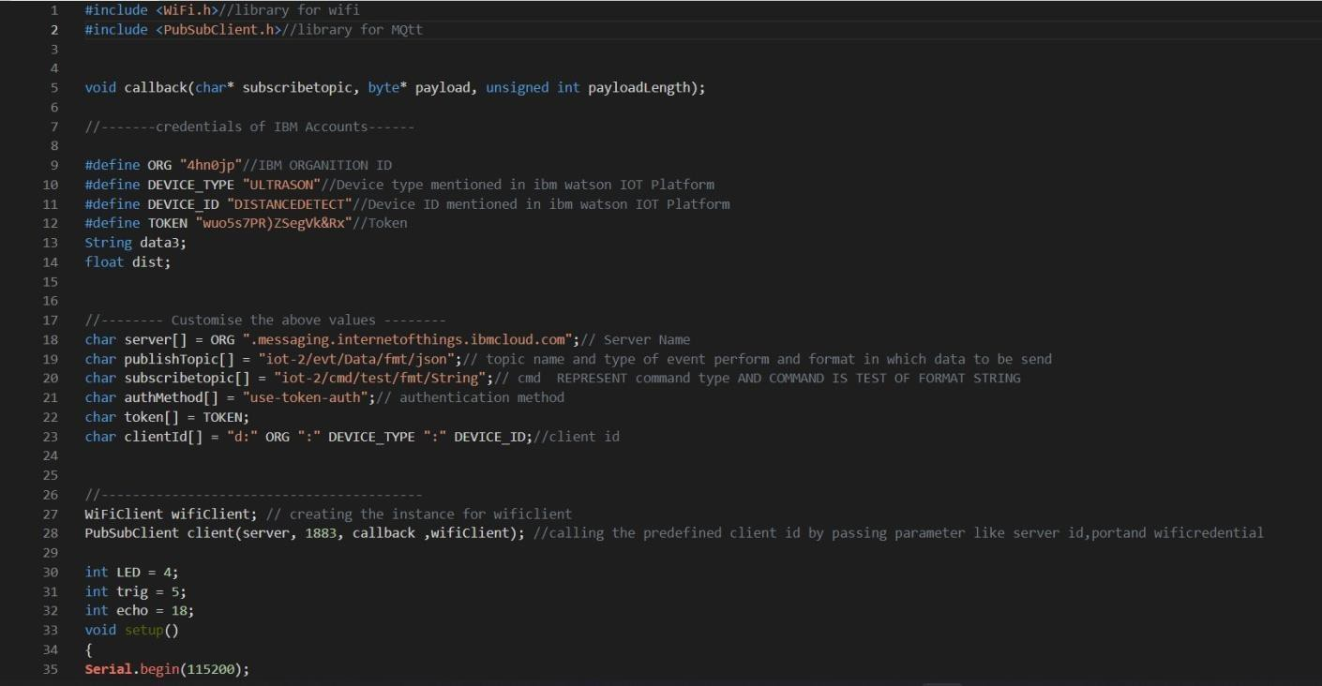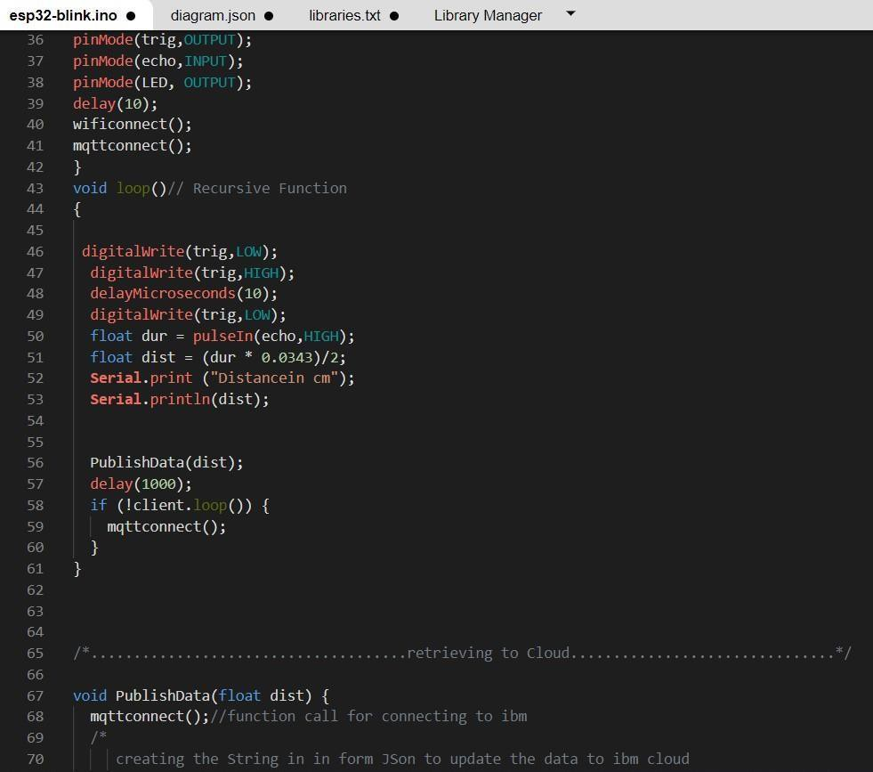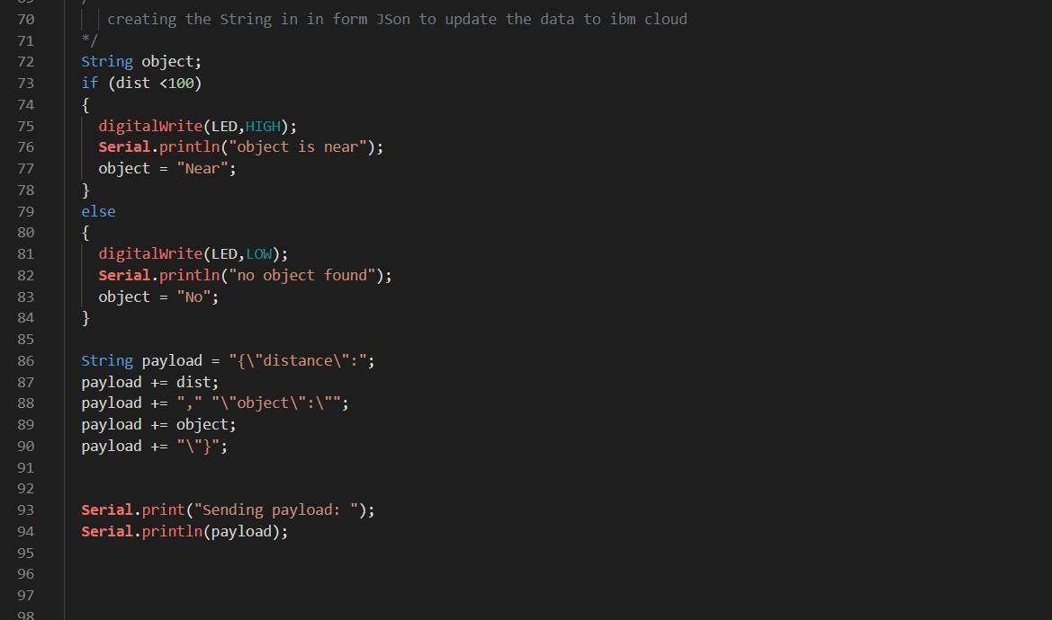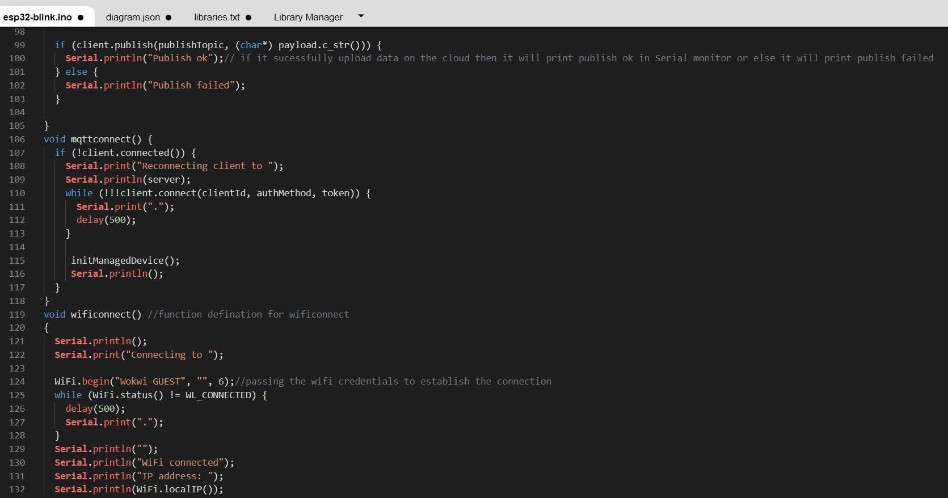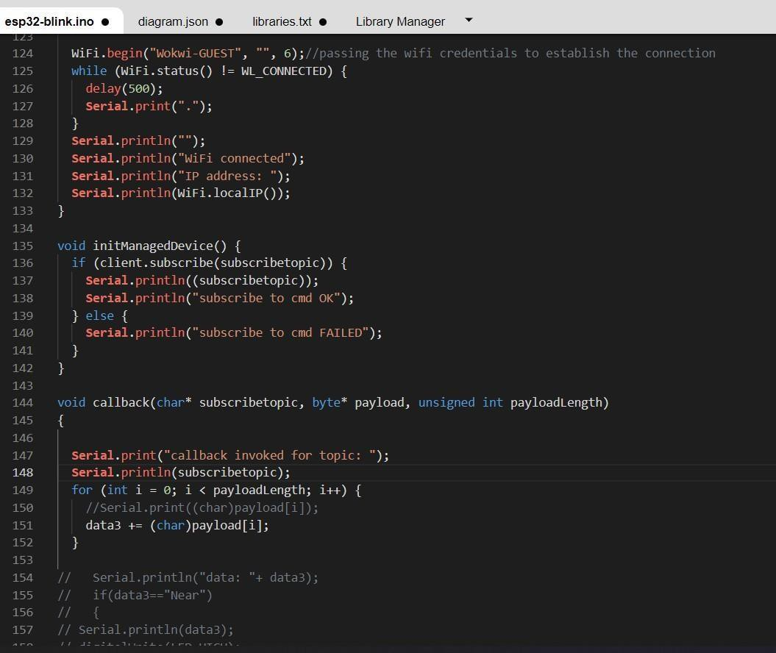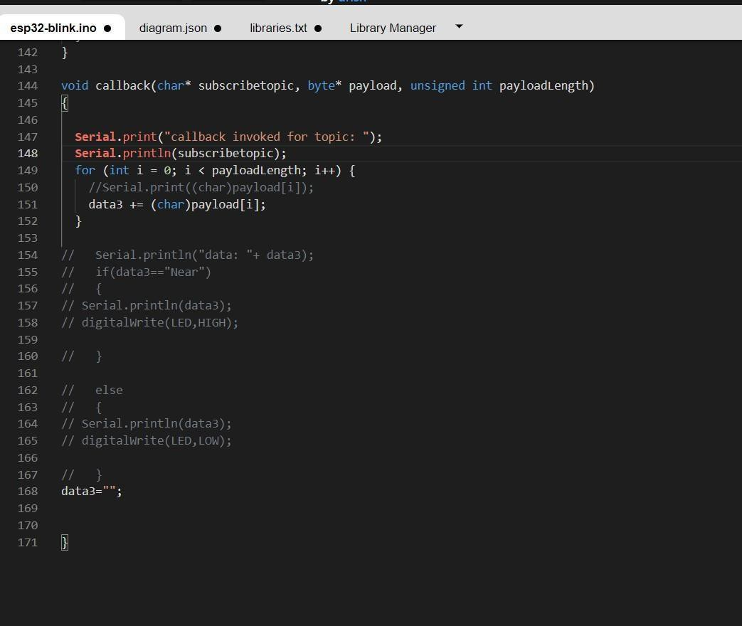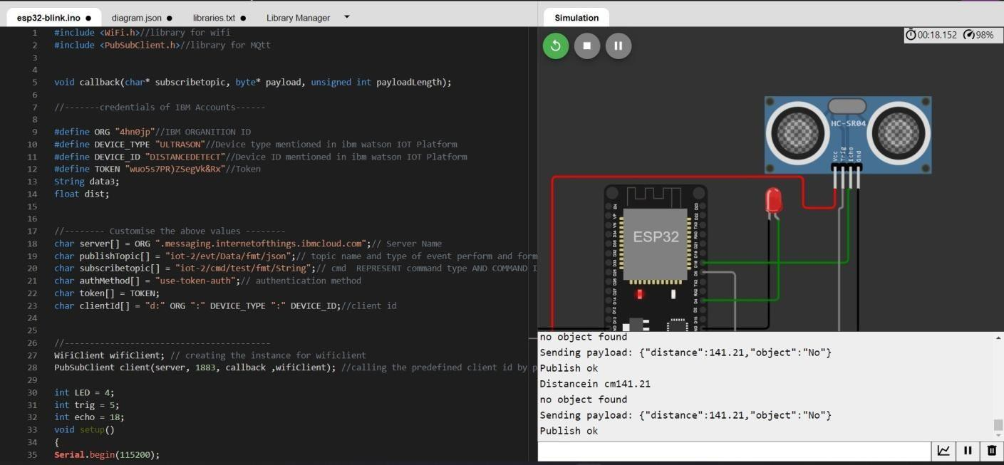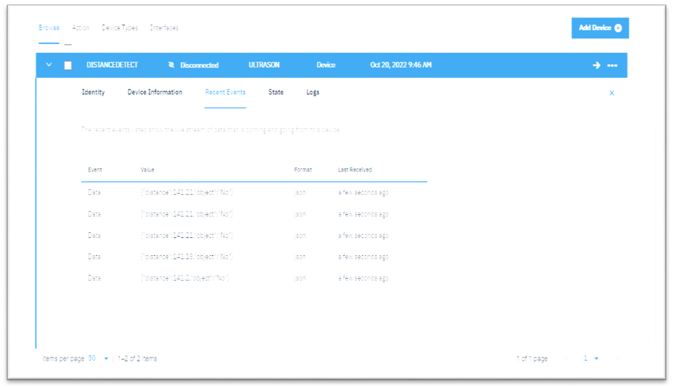

OUTPUT:

Data send to the IBMcloud device when the objectics far

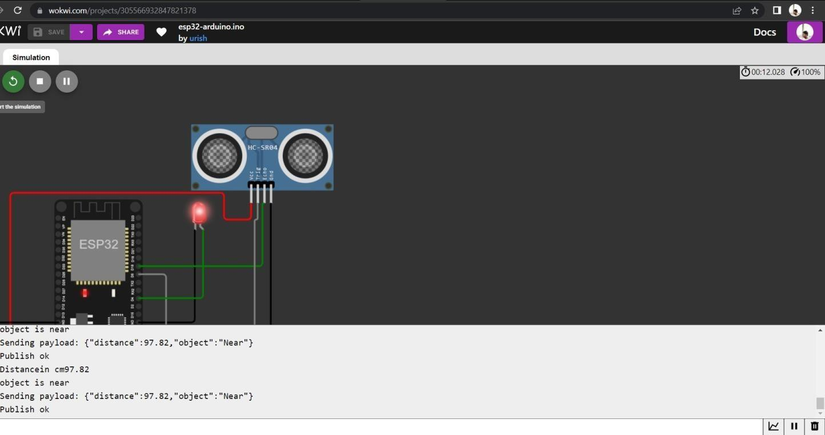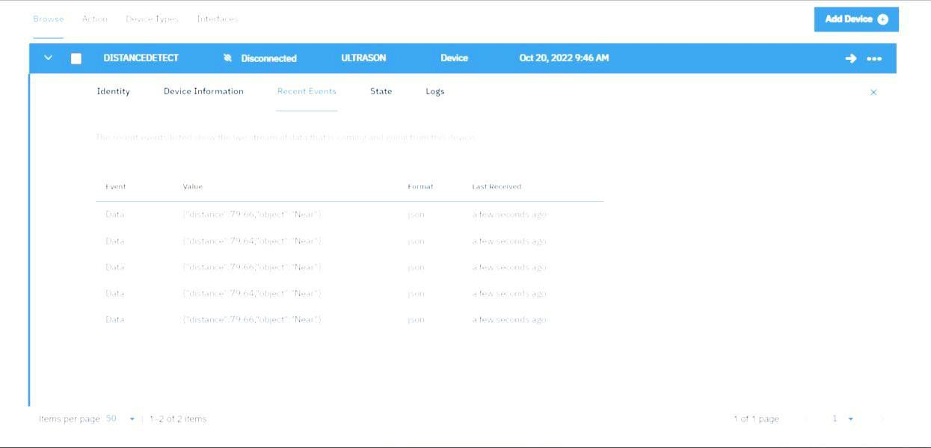

Data sent to the IBMCloud Device when the objectis near

When objectics near to the ultrasonicsensor